The Wolfgang Weber FC Tucson Cup
Rules of Play

All games will be played under IFAB laws of the game as modified by US Club Soccer/USYSA /AYSA) unless otherwise stated herein. The Tournament Director or designated member or members of the Discipline and Rules Committee will settle all disputes. See your Field Marshal for contact information. Tournament rules may be modified under extraordinary circumstances as deemed necessary by the Tournament Director or designee. No protests will be accepted or considered.

Any questions regarding the rules of the tournament or challenges concerning the eligibility of a player should be addressed to the Tournament Director at Tournament Headquarters prior to the beginning of the game.

TOURNAMENT CHECK-IN
Check in instructions are located on the FC Tucson Tournament Website. Check in will be handled all online.

TEAM BRACKET FORMAT
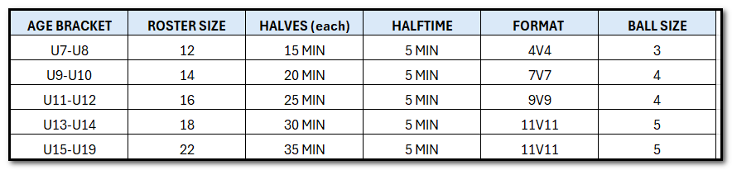
- For halftime breaks, the referee may start the clock for the second half if, in his or her opinion, there has been an unnecessary delay.
- For U-15-U19, all eligible players on the player roster (max 22) can play in all tournament games.

HOME TEAMS
The home team will be the team named first in the game schedule. In the event of uniform color conflict, the home team must change jerseys. The home team will supply the game ball (the ball must meet age group appropriate size and weight and is subject to the approval of the referee), unless tournament officials supply one. The home team will start the game from the north or east side of the pitch.

UNDER 8 4v4 GAMES
Tournament U7/8 games will be 4v4 with no goalkeeper. No offside; no penalty kicks; all free kicks if awarded are indirect. Opponents should be 10 feet away from the ball on restarts. Goal kicks are taken from the goal area or goal line if no goal area is marked on the field. No throw-ins from the touch lines, only kick-ins.
Deliberate heading is not allowed in 4v4 games. If a player deliberately heads the ball in a game, an indirect free kick (IFK) should be awarded to the opposing team from the spot of the offense.
Substitution rules for tournament small sided U8 games are unlimited at any stoppage with the referee’s permission. All other rules for U8 soccer games conform to the LOTG.

UNDER-10 (U9/10) 7v7 GAMES
Tournament U9/10 games are 7v7, including a goalkeeper. In U9/U10 games there is a “build out” line on both sides of the field so that the field appears in thirds. The purpose of the build out line is to allow the team taking a goal kick (or any goalkeeper delivery) to put the ball in play before the opposing team can influence play and advance forward of the build out line. All opponents must retreat behind the build out line during goalkeeper deliveries, including goal kicks, regardless of who takes the goal kick. Teammates of the goalkeeper need not retreat to the line. If the team wants to put the ball into play before the opposition retreats to the build out line, they may do so at their own risk.
Additionally, goalkeepers in the U9/U10 game CAN’T punt the ball. They must throw the ball or roll the ball out when they control the ball with their hands. They are not allowed to “drop-kick” the ball and they can’t place the ball on the ground and kick it.
Furthermore, no heading is allowed by players in U9/U10 games. If they deliberately head the ball, the referee stops play and awards an indirect free kick (IFK) to the opposing team.
One other exception to the U9/10 game is where “offside” will be enforced. The offside is NOT enforced on the halfway line but rather on the build out line in the attacking half of play. Thus, the build out line is treated like the halfway line on a regular field.
Finally, substitution rules for tournament small sided U9/10 games will be in accordance with the US Soccer Player Development Initiatives (PDIs). They are allowed unlimited substitutions at any stoppage, with the referee’s permission. All other rules for U9/10 soccer games conform to the LOTG.

UNDER-11 9v9 GAMES
The tournament U11 games, players are not allowed to head the ball. If, during the U11 game, a player deliberately heads the ball the referee stops play and awards an IFK to the opposing team.
Additionally, substitution rules for tournament small sided U11/12 games will be in accordance with the US Soccer PDIs. They are allowed unlimited substitutions at any stoppage, with the referee’s permission. All other rules for U11/12 soccer games conform to the LOTG

EQUIPMENT
All players are required to wear shin guards under socks. No jewelry may be worn in competition. Players shall wear approved boots (no center cleats). All players must wear numbered (minimum 6” on back of jersey) uniforms with no duplicated numbers on a team.
No player will be permitted to wear anything in a game that could cause or aggravate injury to either that player or any other player; however, orthopedic casts (hard casts) are permitted. The cast must be padded with a closed-cell, slow recovery foam padding no less than ½ inch thick.
NO jewelry is allowed including taped earrings. Players not in compliance will be CAUTIONED (yellow carded) and sent off the field until the requirement is met.

COOLING BREAKS
For the safety of all participants, if the weather is hotter than 85F, then all tournament games will have a mandatory maximum of 2-minute running clock "cooling break" per half enforced by the referee team.

SEATING

Spectators will sit on the same side of the pitch as their team, opposite the side of the Assistant Referee. See diagram below.

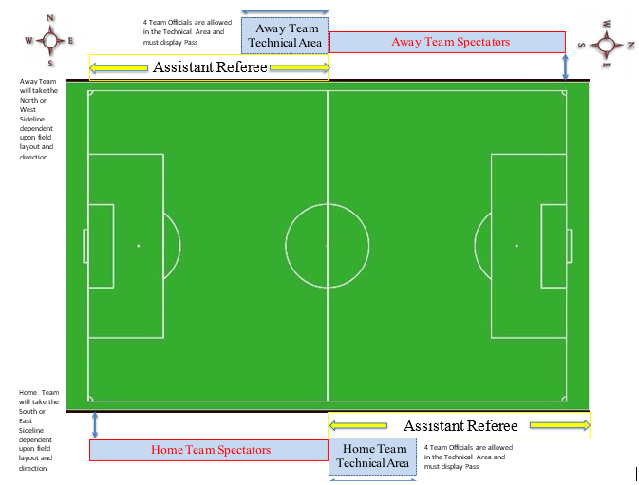

COACHING
All Head coaches have total responsibility for the conduct of their assistant coaches, team officials, players, and spectators at all times. Coaching from the sidelines (giving directions to ones own team on points of strategy and position) is permitted if:

- No mechanical devices are used and the tone of the voice is instructive and not derogatory.
- No coach, team official, player or spectator uses profanity or incites, in any manner, disruptive behavior.
- No coach, team official, player or spectator makes derogatory remarks or gestures to the referees, other coaches, players or spectators.

Both coaches will sign the match card in front of the center referee, when the match is finished, attesting to its accuracy. The Head coach or Team manager is responsible for picking up players passes after each match, if applicable.

GUEST PLAYERS
Each team will be allowed up to 5 guest players with the exception of U7-U10 teams which will be allowed 3 guest players.

DUAL ROSTERED PLAYERS
If a player is rostered on more than one team, that player may only play on one team during the term of the tournament.

FORFEITURES
Teams failing to report ready to play within (5) minutes of scheduled kick-off time may forfeit their match. A team playing 11 a-side must have a minimum of seven (7) players available at the start of the game and during the game to avoid a forfeit. Teams playing in 9 a-side (U11-12s) must have at least six (6) players present. Teams playing in 7 a-side (U-9-10s) must have at least five (5) players present. Teams failing to meet this minimum requirement at any point in the match will forfeit the match. Teams who have forfeited may continue on in the tournament.

REFEREES
All referees working this tournament must be certified by the Federation. All referee decisions are final and not subject to appeal. The center referee will fill out the match card and give it to the Field Marshal/Site Coordinator immediately after the match is finished.

INJURY
Referees will be instructed not to add time to a match except under the most extenuating circumstances. However, all preliminary matches will be terminated not less then (5) minutes prior to the scheduled start of the next match.

CONCUSSION/HEAD INJURY POLICY
Any athlete suspected of sustaining a concussion or head injury shall be immediately removed from tournament play and not permitted to return until he/she has received written clearance from a licensed Medical Doctor (MD or Do). Clearance by Physician Assistants, RN’s or LPN’s will not qualify for state policy. Referee will note on the game card that player suffered Head Injury and was taken out of game. Player pass will be pulled from ring and along with completed injury report given to the Field Marshal. The Field Marshal will give the player a form to be completed by an MD or DO only. Players cleared before the end of tournament, must bring their written clearance to a tournament official (the Field Marshal) before resuming play. The referee will note on game card that the player is being removed due to head injury. Referee will pull the player pass and advise team manager/coach that player pass has been pulled. Written release by MD is required to resume play during the course of the tournament.

SUBSTITUTIONS
Substitutions will be allowed at any stoppage of play, with the center referee’s permission. Entering substitutes must remain on the touch line until the substituting player has left the field, unless permitted to enter earlier by the referee. Players leaving the field will do so by the closest boundary (Touch line or goal line) unless the referee directs something else. If coach/medical personnel go onto the pitch to tend to a player, that player must leave the field until the next stoppage.

TOURNAMENT SCORING
Teams shall be awarded points for match results as follows:
- (3) points for each win
(1) point for each tie (including 0-0 tie)
(0) points for each loss
- For a forfeited match, the winner will be credited with a 1-0 win and awarded (3) points. A maximum of (5) minutes allowed from match time to forfeit time.
- No points will be awarded if neither team shows up.
- Any team leaving the field prior to determination of a winner shall forfeit the match.
- A match is considered official upon completion of one half of play regardless of the circumstances of termination during the second half with final results based on the score at termination.
- Final standings for the pool will be determined by the total number of points accumulated during pool play.
- Scores of each match played will be posted on GotSoccer after the Field Marshal report each match score.

TIE BREAKING WITHIN A POOL
Ties in pool standings will be broken by employing a tiebreaker.
- Head-to-Head (if more than 2 teams are tied, immediately move to tiebreaker #2).
- Largest goal differential (Goals For minus Goals Against with a maximum differential of 6 goals for or against per match).
- Most goals scored (maximum of (6) per match).
- Least goals allowed.
- FIFA penalty kicks (site and time at the discretion of Tournament Director). (11) players from a team (9 players for U11-U12, 7 players for U9-U10) must be ready to participate within (5) minutes of appointed time or else that team will forfeit its opportunity to prevail in the tiebreaker.

TIE BREAKING IN SEMI-FINAL AND CHAMPIONSHIP MATCHES
If the score is still tied at the conclusion of regulation time in any Semi-Final or Championship match, both teams will take penalty kicks as described below until a winner is determined…NO OVERTIME. No Semi-Final or Championship match shall end in a tie.

PK Procedures- Only the (4) U7-U8, the (7) U9-U10, the (9) U11-U12, and the (11) U13-U19 players on the field at the conclusion of regulation may participate. The Center Referee will gather all the players on the field at the end of regulation time and not allow them to go to their respective sidelines. They are the only players who will shoot the PK’s. After the initial (5) PK’s are taken and there is no winner, each team will take an equal number of PK’s (one for one) until a winner is determined. If need be, all (11, 9 or 7) players will be used and then each team will begin again in the same order they started in.

EJECTION’S
Tournament rules prohibit any coach, team official or player ejected from a match, or suspended by the proper authority, to be within sight or hearing distance of the field of play during his/her suspension. A coach, team official or player receiving two cautions (yellow cards) in a single match is considered to have been given an ejection (red card). A player who has been ejected (sent off) shall not be replaced. Players and/ or coaches receiving a red card will be ejected from the game and will not participate in the next scheduled game and other penalties may be assessed depending upon the offense. The player pass will be held by the Discipline and Rules Committee at Tournament Headquarters until the player is eligible to play again.
Any coach, team official or player who assaults a referee will be expelled from the tournament. FIGHTING will not be tolerated for any reason. Coaches, team officials, players or spectators sent off for fighting (striking or attempting to strike another coach, team official, player or spectator) will not be allowed to participate in any further tournament matches. Coaches, team officials, players or spectators who enter the field of play for any reason, in the event of a fight, will be ejected from the tournament. If the coaches, team officials, players or spectators cannot be identified, the entire team will be removed from the tournament. No refunds will be made to any team that is removed from the tournament for fighting or for any other reason. The coach/team official shall forfeit the carded coach’s, team official or player’s pass to the Center Referee for red cards who will give the pass and the match report to the Field Marshal/Site Coordinator. The coach, team official or player in question shall be ineligible until the pass is returned to said coach, team official or player by the Tournament Committee. Any coach or team official that is coaching more than one team in the tournament and is suspended on one team, is automatically suspended from any other teams until the suspension has been served for the team coach was suspended for. If, in the opinion of the Center Referee, a match must be terminated because of misconduct by players, coach(es) or spectators, the offending team forfeits that match and will be suspended from further play in all remaining matches, which would be forfeits. Previous points earned and any awards or other considerations will be forfeited. Any verbal abuse directed at committee members, referees or other volunteers will also result in suspension and ejection. Referees have complete authority during all matches and will not allow abusive or profane language, threats of any kind or any style of play that detracts from the Game of Soccer. All Player/Coach passes must be picked up at the end of the tournament.

ALTERNATE MATCH SCHEDULING
The Tournament Committee has the authority to alter the schedule, move matches to the next day or move match sites for the good of the tournament. All matches will be played if at all possible.

INCLEMENT WEATHER OR UNEXPECTED TERMINATION OF PLAY
Matches will be played in all weather conditions, unless the City of Tucson, Pima County Parks and Recreation, Center Referee, or Tournament Director determines the conditions are dangerous and/or life threatening as per FIFA/US Club Soccer regulations or may cause severe damage to the fields. The Tournament Committee will do everything in their control to make sure all matches are played, but if it is out of their control, the standings at that time will be final. No refunds will be given! If a team forfeits or is suspended by a referee, the other teams scheduled to play that teams remaining matches have no right to a refund.

CONTINGENCY PLAN
Plan A: Tournament start time will be set back the number of time slots required.
Plan B: Shorten all first-round matches to: U7-U8 (10) minute halves, U9-U10 (15) minute halves. U11-U12 20-minute halves, U13-U14 25-minute halves, U15-U17, U19 (30) minute halves.
Plan C: Plan B plus shortens all second round matches the same as Plan B.
Plan D: Plan C plus shortens all second round matches the same as plan C.
Plan E: In the event the fields become totally unplayable, or the weather becomes a safety risk, it may be necessary to decide some matches with FIFA penalty kicks or cancel the tournament play and send the teams home. Tournament placement will be determined by standings at time of tournament stoppage.

DISPUTES
All disputes shall be settled by the Tournament Committee and their decision shall be final. Disputes that will be heard will include player eligibility and tournament rules ONLY! Disputes must be turned in within 20 minutes after match is terminated with both coaches signing the match card that there is a dispute. The dispute will be adjudicated within 20 minutes for a total of 40 minutes after match is finished. Only one (1) person representing the team in dispute will be allowed at the Headquarters tent. NO protests or appeals will be allowed. NO refunds will be issued for any reason after the tournament acceptance letter has been emailed.

AWARDS
All players U12 and under will receive a participation pin. First and second place medals will be awarded to all winning teams in each flight immediately following the championship game. If a flight does not have a championship game and is decided solely on points, medals will be awarded following the last game of flight play. Awards will not be mailed to teams failing to stay for presentations. Please pick up your medals before leaving the field.

RELEASE OF LIABILITY
Once a team is accepted to participate in the FC Tucson Striker’s Cup Tournament, they shall agree to release, hold harmless and indemnify the Tucson Soccer Academy DBA FC Tucson Youth Soccer Club / US Club Soccer/Pima County Junior Soccer League/ The City of Tucson (and their field complexes) / Pima County Parks and Recreation (and their field complexes), and all of the Board members, officials, coaches, referees, medical providers, sponsors and their employees, agents, officers, and directors of the aforementioned entities from any and all liability for injury, or damage to persons, property, or economic interests connected with or arising out of any action taken by them in good faith or out of any failure by them to act. In the event of inclement weather or other uncontrollable force of nature or event, the Tournament Director, the City of Tucson, and Pima County Parks and Recreation shall be the sole and exclusive judge of whether the tournament shall be held, canceled, continued or postponed and we hereby release the FC Tucson Striker’s Cup Tournament and all of the persons or entities mentioned above from any and all liability for direct or consequential damages resulting from the exercise by them of such judgment and recognize and accept all decisions of the tournament as final without objection, appeal or compensation whatsoever. We certify that each player registered by us for the tournament is covered by an approved insurance plan. Payment of entry fee and acceptance to tournament constitutes acceptance of: Release of Liability, tournament guidelines, format, and Tournament Rules.

